Table of Contents

CURRENT DISCOUNT CONFIGURATIONS AVAILABLE ON HQ 3

1 Sale Value Discounts 3

Description 3

Screenshot 3

2 Free of Charge Discounts 4

Description 4

Screenshot 4

3 Discounts Groups 5

Description 5

Screenshot 5

4 Promotion Discounts 6

Description 6

Screenshot 6

5 Product Discounts 7

Description 7

Screenshot 7

6 Certain Value Certain Product 8

Description 8

Screenshot 8

NEW DISCOUNT CONFIGURATION USE CASES 9

Use Case 1 – PROMOTION DISCOUNTS FOR COMBINATION OF SALE PRODUCTS 10

Summary 10

Main Flow 10

Activity Diagram 11

Use Case 2 – PROMOTION DISCOUNTS FOR COMBINATION OF BRANDS 12

Summary 12

Main Flow 12

Activity Diagram 13

Use Case 3 – SET VARYING PERCENTAGE DISCOUNT GROUPS ON HQ 14

Summary 14

Main Flow 14

Activity Diagram 15

Creation of Varying Percentage Discount Group 15

Sale of Product within a Varying Percentage Discount Group 16

Use Case 4 – SALE VALUE BY BRAND PROMOTION DISCOUNT 17

Summary 17

Main Flow 17

Activity Diagram 18

# CURRENT DISCOUNT CONFIGURATIONS AVAILABLE ON HQ

## 1 [Sale Value Discounts](http://197.248.2.53:205/csdistributr_distributr_hq/Admin/SaleValueDiscount/ListSaleValueDiscounts)

### Description

* This discount configuration allows for the HQ Admin to set a certain percentage discount to Outlets within a particular Pricing Tier (e.g. Retail Outlets or Wholesale Outlets)
* The percentage discount is applied once a set minimum Sale Value threshold has been met.
* An effective period for the discount can also be set (Effective Start Date : End Date)
* If:
  + Outlet is within the set Pricing Tier,
  + The set minimum Sale Value threshold is met,
  + The sale is done during the effective period of the discount,

Then the set percentage discount is effected on the total sale value.

### Screenshot

The Screenshot below shows how the Discount is configured on HQ and the parameters/fields that are input when setting up the discount.

Sale Value Discount

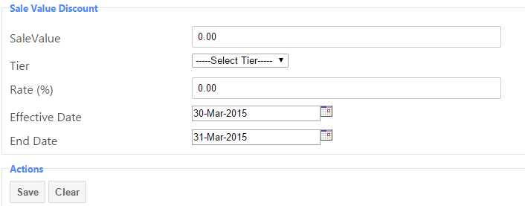

## 2 [Free of Charge Discounts](http://197.248.2.53:205/csdistributr_distributr_hq/Admin/FreeOfChargeDiscount/List)

### Description

* This discount configuration allows for the HQ Admin to set a certain product to be given free of charge by salesmen on Mobile and Hub POS for sales done during a set effective period.
* The Free of Charge product is obtained from the main sale products list.

### Screenshot

The Screenshot below shows how the Discount is configured on HQ and the parameters/fields that are input when setting up the discount.

Free of Charge Discount

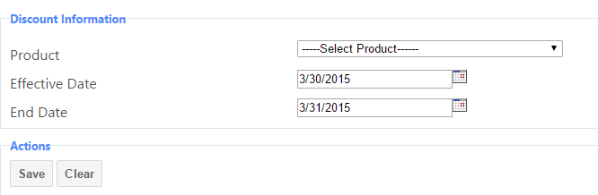

## 3 [Discounts Groups](http://197.248.2.53:205/csdistributr_distributr_hq/Admin/DiscountGroup/ListDiscountGroups)

### Description

* This discount configuration allows for the HQ Admin to create a Discount Group.
* After creating the Discount Group, the HQ Admin may add products to the discount group to be sold at a set percentage discount.
* The HQ Admin may then assign Outlets to the created Discount Group.
* Sales of products that have been added to the Discount Group to Outlets that have been assigned the Discount Group would result in the product being sold at the percentage discount set.
* The HQ Admin may also set the Discount such that only when a certain minimum quantity of the product is sold is when the discount is effected.
* The HQ Admin also sets the effective period of the discount (Effective Start Date : End Date)

### Screenshot

The Screenshot below shows how the Discount is configured on HQ and the parameters/fields that are input when setting up the discount.

Discount Group

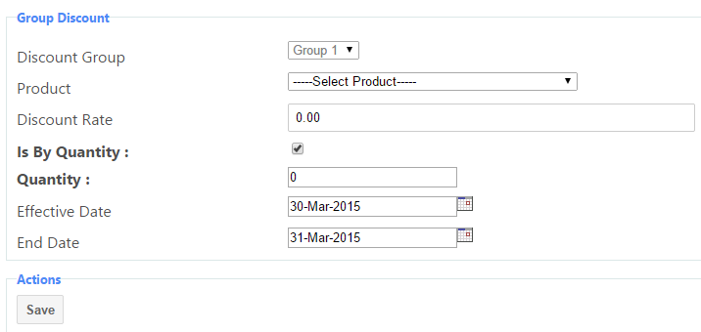

## 4 [Promotion Discounts](http://197.248.2.53:205/csdistributr_distributr_hq/Admin/PromotionDiscount/ListFOCDiscounts)

### Description

* This discount configuration allows for the HQ Admin to set a Promotion Discount; by selling a set number of a particular product, a set number of the same/different product is given for free. For instance, Buy 5 units of Product A and get 2 units of Product B for free.
* The HQ Admin also sets the effective period of the discount (Effective Start Date : End Date)

### Screenshot

The Screenshot below shows how the Discount is configured on HQ and the parameters/fields that are input when setting up the discount.

Promotion Discount

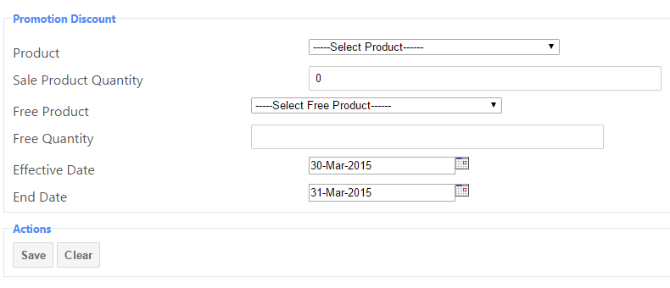

## 5 [Product Discounts](http://197.248.2.53:205/csdistributr_distributr_hq/Admin/ProductDiscount/ListDiscounts)

### Description

* HQ Admin may set a Product Discount that would result in the product being sold at a set percentage discount.
* HQ Admin selects the Product, the Pricing Tier of the product and enters the percentage discount.
* The HQ Admin may also set the Discount such that only when a certain minimum quantity of the product is sold is when the discount is effected.
* The HQ Admin also sets the effective period of the discount (Effective Start Date : End Date)

### Screenshot

The Screenshot below shows how the Discount is configured on HQ and the parameters/fields that are input when setting up the discount.

Product Discount

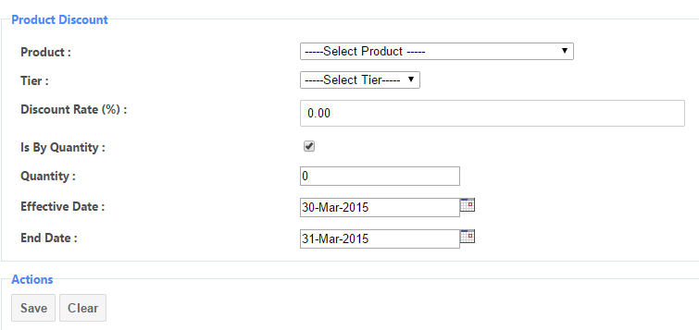

## 6 [Certain Value Certain Product](http://197.248.2.53:205/csdistributr_distributr_hq/Admin/CertainValueCertainProduct/ListCertainValueCertainProduct)

### Description

* This discount configuration allows for the HQ Admin to set a certain product to be given free of charge by salesmen on Mobile and Hub POS once a minimum Sale Value threshold has been met.
* The HQ Admin also sets the effective period of the discount (Effective Start Date : End Date)

### Screenshot

The Screenshot below shows how the Discount is configured on HQ and the parameters/fields that are input when setting up the discount.

Certain Value Certain Product Discount

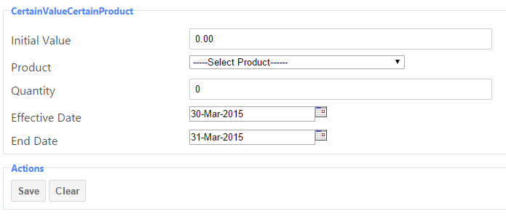

# NEW DISCOUNT CONFIGURATION USE CASES

Below are Use Case documents detailing the new Discount Configurations that have been requested by clients.

The Discount Configurations are:

1. Promotion Discount for Combination of Sale Products
2. Promotion Discount for Combination of Brands
3. Varying Percentage Discount Groups
4. Sale Value By Brand Promotion Discount

# Use Case 1 – PROMOTION DISCOUNTS FOR COMBINATION OF SALE PRODUCTS

## Summary

|  |  |
| --- | --- |
|  | Description |
| Use Case Name: | PROMOTION DISCOUNTS FOR COMBINATION OF SALE PRODUCTS |
| Description: | 1. *HQ Admin should be able to set a Promotion Product on HQ such that when a certain combination of products is sold, a particular product is given free; for instance, 5 Units of Product A + 5 Units of Product B results in 1 Unit of Product C being given for free.* |
| Actors: | *HQ Admin – This User uses the Distributr HQ Module. This User is responsible for the data stored in HQ and is authorized to make edit this data when required.* |
| Pre-Conditions: | 1. *When a certain combination of products of specific quantities is sold, a certain product is to be given for free.* |
| Triggers: | 1. *When the set combination of products of specific quantities is sold, the set free product(s) is to automatically be added to the invoice when making a sale on Mobile or Hub POS.* |
| Post-Conditions: | 1. *The set free product(s) is automatically added to shopping cart when the set promotional discount products have been added to cart.* |

## Main Flow

|  |  |
| --- | --- |
| Step | Flow of Events |
|  | HQ Admin selects PROMOTION DISCOUNTS BY PRODUCT from HQ Distributr Dashboard screen. |
|  | User selects Add Promotion Discount. |
|  | User selects first product from dropdown list of products that have been added on HQ. |
|  | User enters the number of units of the product that would need to be sold for the promotion discount to take effect. |
|  | User can choose to ADD ANOTHER PRODUCT or proceed to add the Free Product from dropdown list of all the products added on HQ. |
|  | If User selects ADD ANOTHER PRODUCT, a dropdown list of all the products added on HQ is displayed. |
|  | User selects the second product and enters the number of units of the product that would need to be sold for the promotion discount to take effect. |
|  | User can choose to ADD ANOTHER PRODUCT or proceed to add the Free Product from dropdown list of all the products added on HQ. |
|  | User should be allowed to add as many products as required. |
|  | After adding all the products, user can then add the Free Product by selecting from dropdown list of all products that have been added on HQ. |
|  | User then enters the number of units that are to be given for free. |
|  | User then sets an effective period for the discount (Effective Start Date : End Date) |

## Activity Diagram



# Use Case 2 – PROMOTION DISCOUNTS FOR COMBINATION OF BRANDS

## Summary

|  |  |
| --- | --- |
|  | Description |
| Use Case Name: | PROMOTION DISCOUNTS FOR COMBINATION OF BRANDS |
| Description: | 1. *HQ Admin should be able to set a Promotion Product on HQ such that when a certain combination of product brands is sold, a particular product is given free; for instance, 5 Units of products of Brand A + 5 Units of products of Brand B results in 1 Unit of Product Z being given for free.* |
| Actors: | *HQ Admin – This User uses the Distributr HQ Module. This User is responsible for the data stored in HQ and is authorized to make edit this data when required.* |
| Pre-Conditions: | 1. *When a certain combination of brands of specific quantities is sold, a certain product is to be given for free.* |
| Triggers: | 1. *When the set combination of product brands of specific quantities is sold, the set free product(s) is to automatically be added to the invoice when making a sale on Mobile or Hub POS.* |
| Post-Conditions: | 1. *The set free product(s) is automatically added to shopping cart when the set promotional discount brand products have been added to cart.* |

## Main Flow

|  |  |
| --- | --- |
| Step | Flow of Events |
|  | HQ Admin selects PROMOTION DISCOUNTS BY BRAND from HQ Distributr Dashboard screen. |
|  | User selects Add Promotion Discount By Brand. |
|  | User selects first Brand from dropdown list of Brands that have been added on HQ. |
|  | User enters the number of units of the product brand that would need to be sold for the promotion discount to take effect. |
|  | User can choose to ADD ANOTHER BRAND or proceed to add the Free Product from dropdown list of all the products added on HQ. |
|  | If User selects ADD ANOTHER BRAND, a dropdown list of all the Brands added on HQ is displayed. |
|  | User selects the second Brand and enters the number of units of the product brand that would need to be sold for the promotion discount to take effect. |
|  | User can choose to ADD ANOTHER BRAND or proceed to add the Free Product from dropdown list of all the products added on HQ. |
|  | User should be allowed to add as many Brands as required. |
|  | After adding all the brands, user can then add the Free Products by selecting from dropdown list of all products that have been added on HQ. |
|  | User then enters the number of units that are to be given for free. |
|  | User then sets an effective period for the discount (Effective Start Date : End Date) |

## 

## Activity Diagram



# Use Case 3 – VARYING PERCENTAGE DISCOUNT GROUPS

## Summary

|  |  |
| --- | --- |
|  | Description |
| Use Case Name: | SET VARYING PERCENTAGE DISCOUNT GROUPS ON HQ |
| Description: | 1. *This discount configuration allows for the HQ Admin to create a Varying Percentage Discount Group.* 2. *After creating the Discount Group, HQ Admin may add products to the discount group to be sold at varying percentage discount rates (for instance, a 5-10% discount is given)* 3. *The HQ Admin may then assign Outlets to the created Varying Percentage Discount Group.* 4. *The different allowable percentage discounts per product are set at HQ.* 5. *It is left to the discretion of the Salesman using the Mobile App on route or Hub POS as to which discount rate to apply during a sale at an Outlet assigned to the Varying Percentage Discount Group.* |
| Actors: | *HQ Admin – This User uses the Distributr HQ Module. This User is responsible for the data stored in HQ and is authorized to make edit this data when required.* |
| Pre-Conditions: | 1. *The products being added to the Varying Percentage Discount Group have an effective price set.* 2. *The Outlets have been assigned the same Varying Percentage Discount Group.* 3. *The different allowable discount rates are set at HQ.* |
| Triggers: | 1. *The Salesman on route or selling from Hub POS is authorised to give a product discount within a certain percentage range to particular Outlets that have been assigned to the Varying Percentage Discount Group.* |
| Post-Conditions: | 1. *The Salesman using the Mobile App on route or Hub POS selects the discount rate to apply on products belonging to the Varying Percentage Discount Group during a sale at an Outlet assigned to the same Varying Percentage Discount Group.* 2. *The sale price of the product is adjusted based on the discount rate selected.* |

## Main Flow

|  |  |
| --- | --- |
| Step | Flow of Events |
|  | HQ Admin selects DISCOUNT GROUP menu from HQ Distributr Dashboard screen. |
|  | HQ Admin creates a Varying Percentage Discount Group. |
|  | After creating the Discount Group, the HQ Admin may add products to the discount group |
|  | HQ Admin then assigns Outlets to the Varying Percentage Discount Group |
|  | Salesman selects an Outlet assigned to the Varying Percentage Discount Group when making a sale on Mobile or Hub POS. |
|  | Salesman selects a product assigned to the same Varying Percentage Discount Group |
|  | After selecting the product, user is redirected to Summary Screen. |
|  | When on the Summary Screen, User can click on the product assigned to the Varying Percentage Discount Group and select the discount rate to apply based on the set rates on HQ. |
|  | The selling price of the product is adjusted based on the selected discount rate. |

## Activity Diagram

### Creation of Varying Percentage Discount Group



### Sale of Product within a Varying Percentage Discount Group

### 

# Use Case 4 – SALE VALUE BY BRAND PROMOTION DISCOUNT

## Summary

|  |  |
| --- | --- |
|  | Description |
| Use Case Name: | SALE VALUE BY BRAND PROMOTION DISCOUNT |
| Description: | 1. *HQ Admin should be able to set a promotion product discount when sales of products of a particular brand (or combination of brands) reach a set minimum sale value.* 2. *Once the set minimum Sale Value has been met by the sale of products of a particular brand (or combination of brands), a set number of products is given free.* 3. *The HQ Admin also sets the effective period of the discount (Effective Start Date : End Date)* |
| Actors: | *HQ Admin – This User uses the Distributr HQ Module. This User is responsible for the data stored in HQ and is authorized to make edit this data when required.* |
| Pre-Conditions: | 1. *The sale products have been defined by Brand on HQ.* 2. *The sale products have an effective price set on HQ.* |
| Triggers: | 1. *One or more units of a particular product is to be given free when sales of products of a particular brand (or combination of brands) reach a set minimum sale value threshold.* |
| Post-Conditions: | 1. *Once the minimum sale value threshold of products of a particular brand (or combination of brands) is met, a pre-set product is to be given free.* |

## Main Flow

|  |  |
| --- | --- |
| Step | Flow of Events |
|  | HQ Admin selects SALE VALUE BY BRAND PROMOTION DISCOUNT menu from HQ Distributr Dashboard screen. |
|  | User selects the required Brand from drop-down list of Brands already created on HQ. |
|  | User can choose to ADD ANOTHER BRAND or proceed to enter the minimum Sale Value that would result in the free product being given out. |
|  | If User selects to ADD ANOTHER BRAND, a drop-down list of brands in HQ is displayed. |
|  | Once User has selected the second brand, User can then ADD ANOTHER BRAND or proceed to enter the minimum Sale Value that would result in the free product being given out. |
|  | User should be allowed to add as many brands as required. |
|  | Once User has added all the required Brand Names, User can then set the minimum Sale Value threshold that would result in the free product being given out. |
|  | Once User has set the minimum Sale Value that would result in the giving out of the free product, the product that is to be given free is then selected from drop-down list of all the products that have been created on HQ. |
|  | Once User has selected the required product that is to be given free, the User enters the number of units of that particular product that would be given free. |
|  | User would then set the effective period of the discount (Effective Start Date : End Date) |

## Activity Diagram

